Preliminary report

Data base design
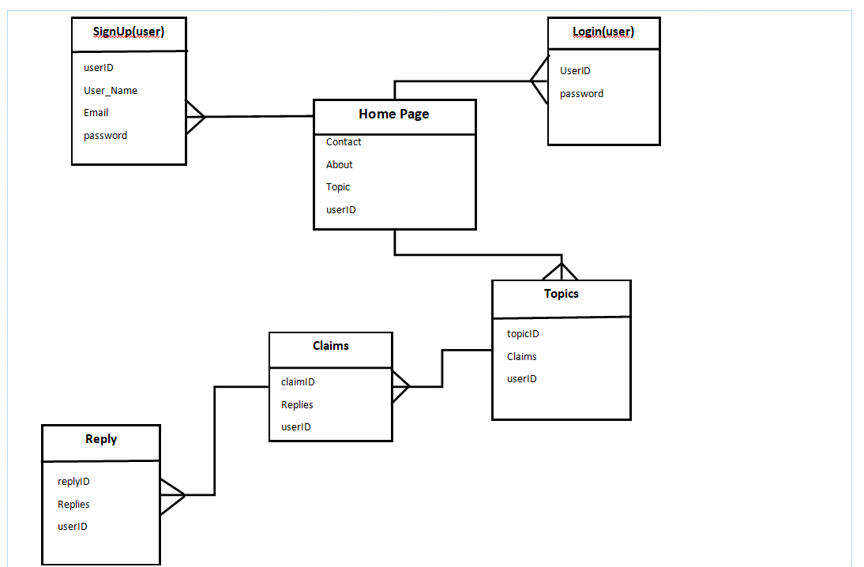
Wireframes representing the user interface
Server-side functionality
The server-side will hold the functionalities to various requests made from the browser by the client. Requests will be sent in various ways which can be when a link is clicked, form is submitted, request to login or run a search. The requests will include URL identifying the affected resource plus a method defining the required action.
The server-side will also hold functionalities which wait and process client request messages, process them and send back replies with an http response message containing a status line to indicate whether the request was successful or unsuccessful.
When a reply is successful, the body will contain the requested source. The functionalities on the server-side will be in place to handle requests that include:
- HTML
- Login
- Submit register form
- Edit profile
- Delete profile
- Click on a link
- Etc.
Client-side functionalities
On the client-side, there will base functionalities that allow users/client to make requests and navigate through the website to the different pages. These will be functionalities to:
- When a button is clicked to sign in, Sign Up/register
- When a user posts a topic, adds a claim, adds a reply, or reply to reply.
- The functionality to display forms that include edit profile, login, Signup.
- The functionality which requests for a search
- The functionality to actions such as, hover
- The functionalities to display an overlay
- Plus all other functionalities that will enable the user to manipulate the web application in the browser.

1.Home page with posted topics
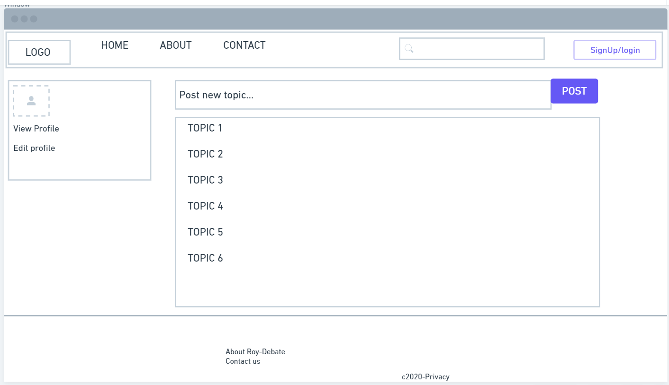

2.Overlay displaying the claims to a topic
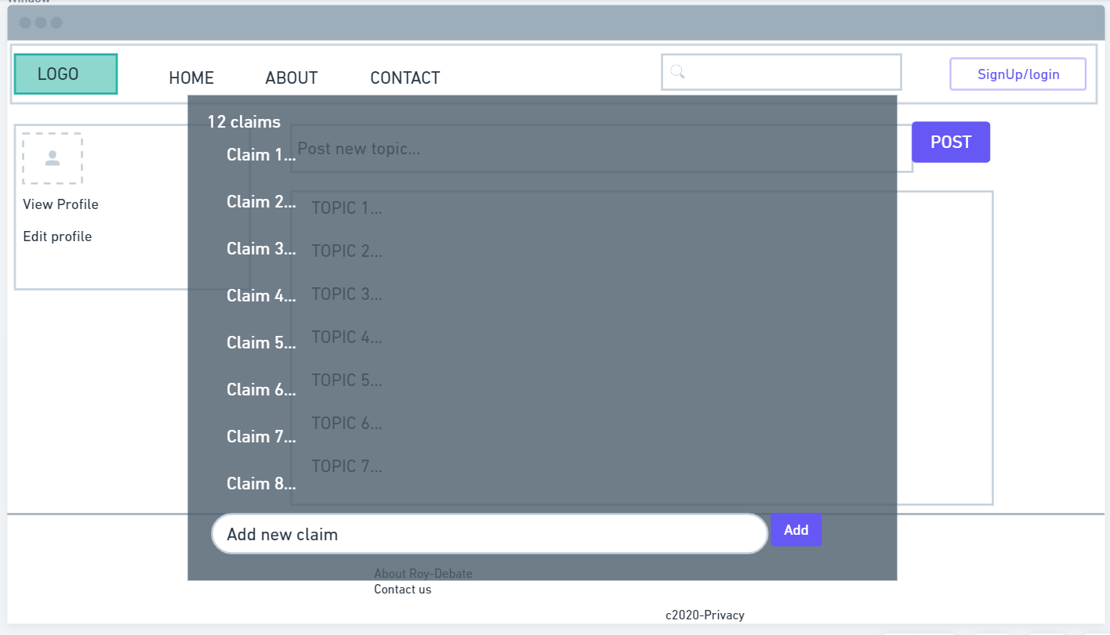

3.Claim page displaying selected claims and its replies
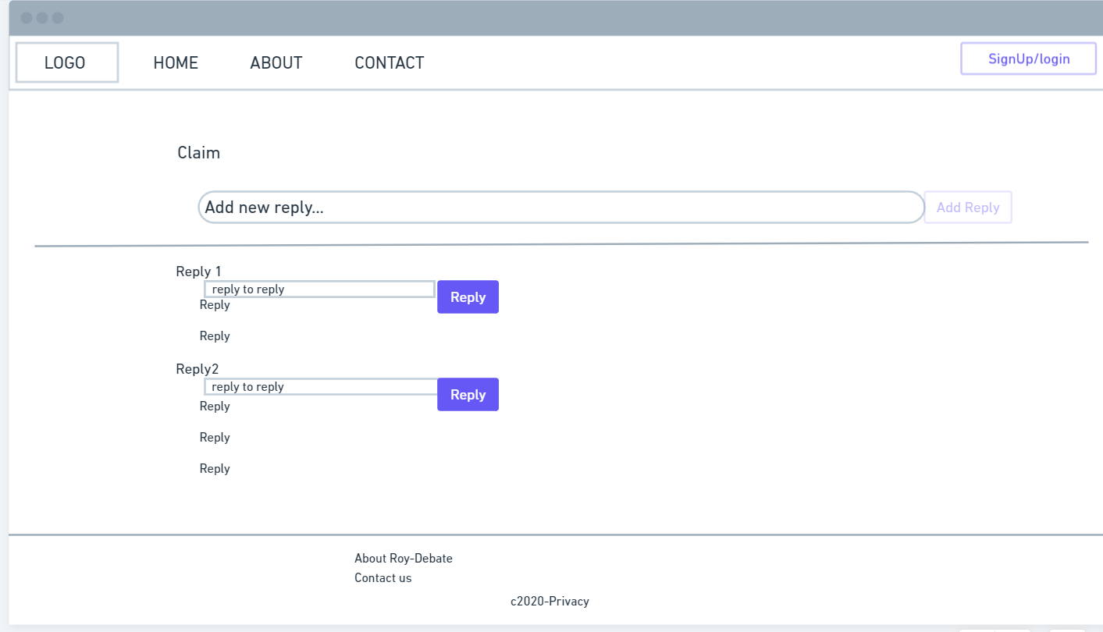

4.Overlay of the login
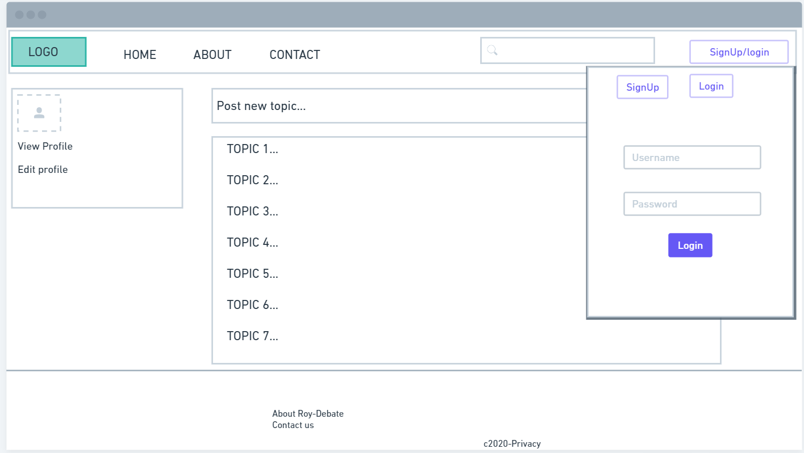

5.Overlay of signup form
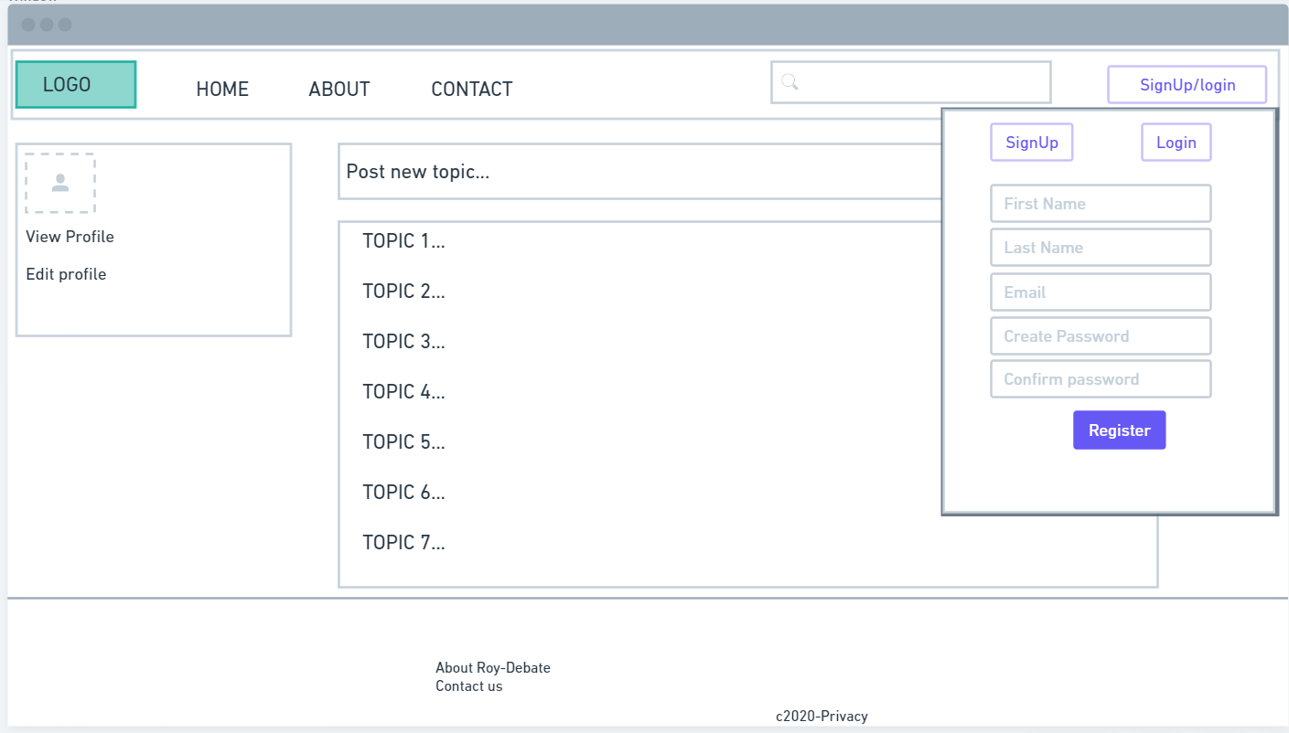

Overview of the intended implementations
On client-side.
On the client-side, implementations will be made using JavaScript to perform tasks such as validating, sending commands to web API, querying a web for data, selecting HTML elements and updating/retrieving values.
Will also involve other libraries such as jQuery to make for simplifying some of the more complex tasks. Tracking code will be deployed on each page via a tag management system which will send data to the appropriate server via the users’ browser.

On server-side
The server will get a pixel of data sent to it and pass it to its destination without the need to send a response back to the website. The data will then be available to be loaded into an analytics platform, this I have discovered to be a much more efficient process.

